**Ex. No.: 11a)**

**Date: 07-04-2025**

**FIFO PAGE REPLACEMENT**

**Aim:**

To find out the number of page faults that occur using First-in First-out (FIFO) page replacement technique.

**Algorithm:**

1. Declare the size with respect to page length

2. Check the need of replacement from the page to memory

3. Check the need of replacement from old page to new page in memory 4. Form a queue to hold all pages

5. Insert the page require memory into the queue

6. Check for bad replacement and page fault

7. Get the number of processes to be inserted

8. Display the values

**Program Code:**

#include <stdio.h>

int main() {

int referenceString[50], frames[10], n, frameSize;

int i, j, k, pageFaults = 0, isHit, nextToReplace = 0;

printf("Enter the size of reference string: ");

scanf("%d", &n);

for (i = 0; i < n; i++) {

printf("Enter [%d] : ", i + 1);

scanf("%d", &referenceString[i]);

}

printf("Enter page frame size : ");

scanf("%d", &frameSize);

for (i = 0; i < frameSize; i++) {

frames[i] = -1; // Initialize frames as empty

}

printf("\n");

for (i = 0; i < n; i++) {

isHit = 0;

// Check if the page is already in memory

for (j = 0; j < frameSize; j++) {

if (frames[j] == referenceString[i]) {

isHit = 1;

break;

}

}

if (!isHit) {

// Replace the oldest page (FIFO)

frames[nextToReplace] = referenceString[i];

nextToReplace = (nextToReplace + 1) % frameSize;

pageFaults++;

// Print memory contents

printf("%d -> ", referenceString[i]);

for (k = 0; k < frameSize; k++) {

if (frames[k] != -1)

printf("%d ", frames[k]);

else

printf("- ");

}

printf("\n");

} else {

printf("%d -> No Page Fault\n", referenceString[i]);

}

}

printf("\nTotal page faults: %d\n", pageFaults);

return 0;

}

**OUTPUT:**

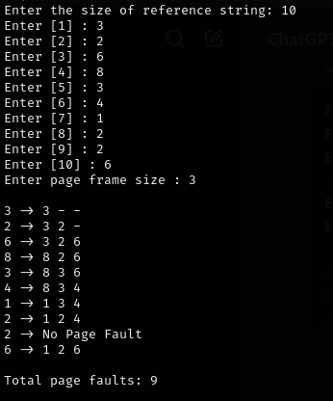

**RESULT:**

Hence, page faults that occur using First-in First-out (FIFO) page replacement technique has been found.